
Year 8 Investigation 3

Linear Models

Name: _______________________ / 40 marks
Time: 50 minutes

The school is planning a disco for all the year 9 students. It is your job to organize the music for the night. You have found the following 3 alternatives for the music.

Choice 1 - Rick’s Rock Group
Rick charges $100 per hour and but charges a flat fee of $20 for coming out

Choice 2 - Magic Mark DJ service
Mark charges $40 per hour plus a $200 flat fee.

Choice 3 - Steve’s Death Metal Band.
Steve charges $60 per hour plus a $100 flat fee.

- Complete the table of values for each option and write a rule using “C” for cost and “N” for Number of hours that could be used for each option. [8 marks]

Rick’s Rock Group
N (number of hours) | 0 | 1 | 2 | 3 | 4 | 5 | 6
C (cost in $) | 20 | 120

Now write a rule you can use to calculate the cost of Rick’s Rock Group.

$$C = _________ n + __________$$

Magic Mark’s DJ Service.
N (number of hours) | 0 | 1 | 2 | 3 | 4 | 5 | 6
C (cost in $) | 200 | 240

Now write a rule you can use to calculate the cost Magic Mark’s DJ Service.
$$C = ________ n + __________$$

Steve’s Death Metal Band.
N (number of hours) | 0 | 1 | 2 | 3 | 4 | 5 | 6
C (cost in $) | 100 | 160

Now write a rule you can use to calculate the cost Steve’s Death Metal Band.
$$C = ____________ + ____________$$
- Plot these three options on the graph paper provided. Label each option and the axes. [10 marks]

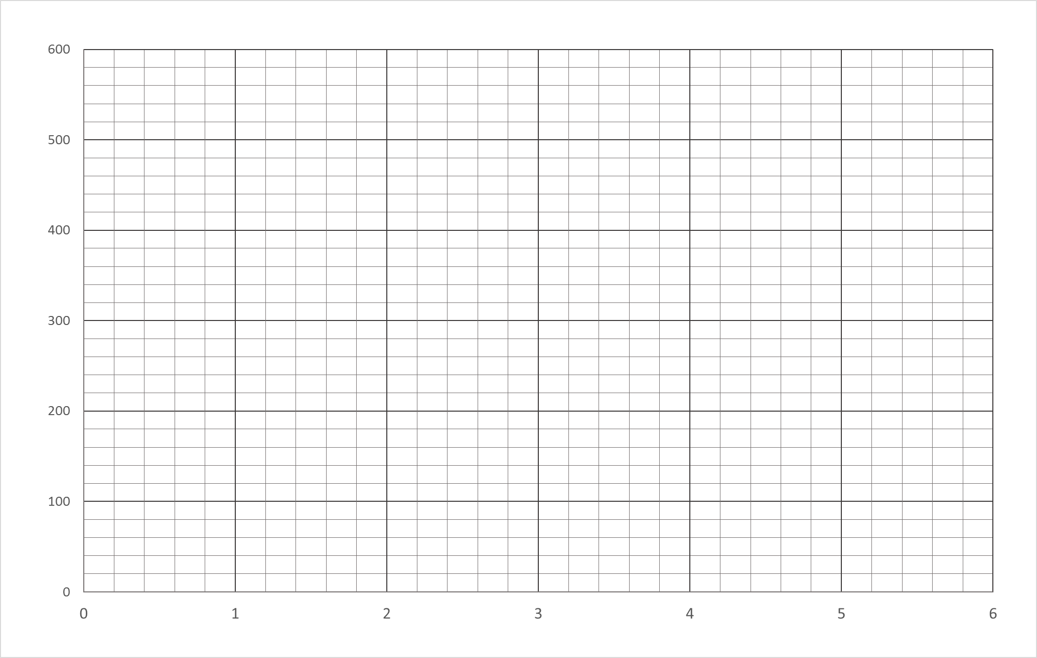

- Which music group is the cheapest in the first 2 hours? [1 mark]

- Which music group is the cheapest after 4 hours? [1 mark]

- Which music group is the cheapest after 6 hours? [1 mark]

- Which option is the best value if the disco is to go for 1 hours? [1 mark]

- How much will the cheapest music act cost if the disco goes for 4 hours? [1 mark]

  - The principal has set the times for the disco from 7pm until 10:30pm. Using your graph, find out what the cost would then be for each of the three options. [3 marks]

Rick’s Rock Group Magic Mark’s DJ Steve’s Death Metal

  - Check that these values are correct by substituting N (number of hours) back into your rule to find the cost. Show your working. [6 marks]

Rick’s Rock Group | Magic Mark’s DJ | Steve’s Death Metal
C = 100 ×_____ + 20  C = _________ + 20  C = $ _______ | C = 40 ×_____ + 200  C = _________ + 200 | C = 60 ×_____ + 100

- If you are given a budget of $300, how many hours could you hire Magic Mike’s DJ service for?
[1 mark]

- Sales of tickets has resulted in 30 tickets getting bought at $10 each. Using the total money raised which band would be able to play the longest? Explain your answer. [2 marks]

- If an additional 15 tickets are sold would this change which group you would choose? Explain your answer. [2 mark]

- If I were to pay Steve’s Death Metal Band $1000 to play at my birthday how many hours could I hire them for? Create and solve a linear equation to prove your answer. [3 marks]

End of Assessment

